1. Write a method named square cube () that computes the square and cube of the value passed to it and display the result. Ask the user to provide the integer input in the main () and then call the function.

**Solution:**

static void square_cube(int n)

{

int sqr, cube;

sqr = n * n;

cube = n * n * n;

Console.WriteLine("\n\tSquare of the number is: "+ sqr);

Console.WriteLine("\tcube of the number is: "+ cube);

}

static void Main(string[] args)

{

Console.Write("Enter number: ");

int n = int.Parse(Console.ReadLine());

square_cube(n);

}

**Output:** 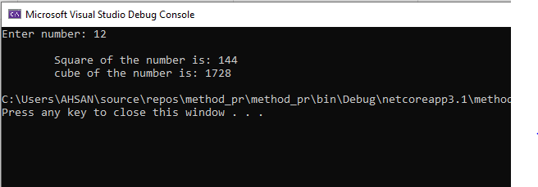

1. Write a method table () which generates multiplicative table of an integer. The function receives three integers as its arguments. The first argument determine the table to be generated while the second and the third integer tell the starting and ending point respectively. Ask the user to provide the three integer as input in the main ().

**Solution:**

static void table(int x, int y, int z )

{

Console.WriteLine();

for (int i = y; i <= z; i++)

{

Console.WriteLine("{0} x {1} = {2} ",x,i,x*i);

}

}

static void Main(string[] args)

{

Console.Write("enter (table) number: ");

int x = int.Parse(Console.ReadLine());

Console.Write("enter number from where table to be start: ");

int y = int.Parse(Console.ReadLine());

Console.Write("enter number from where table to be end: ");

int z = int.Parse(Console.ReadLine());

table(x, y, z);

}

**Output:** 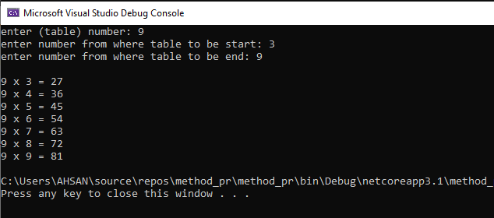

1. Create two function to find min and maximum value of any int array.

**Solution:** static void max(int n,int[] arr)

{

int max = 0;

for (int i = 0; i < n; i++)

{

if (i == 0)

{

max = arr[i];

}

if (arr[i] > max)

{

max = arr[i];

}

}

Console.WriteLine("maximum num in array: " + max);

}

static void min(int n, int[] arr)

{int min = 0;

for (int i = 0; i < n; i++)

{

if (i == 0)

{

min = arr[i];

}

if (min > arr[i])

{

min = arr[i];

}

}

Console.WriteLine("minimum num in array: {0}", min);

}

static void Main(string[] args)

{

Console.Write("enter length of an array: ");

int n = int.Parse(Console.ReadLine());

int[] arr = new int[n];

Console.WriteLine("enter series");

for (int i = 0; i < n; i++)

{

arr[i] = int.Parse(Console.ReadLine());

}

max(n,arr);

min(n,arr);

**Output:**

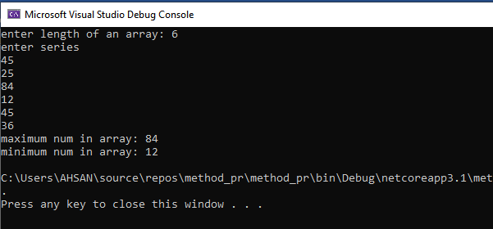

1. Take input of an array in on method and print reverse of that array.

**Solution:**

{

Console.Write("enter the size of array: ");

int n = int.Parse(Console.ReadLine());

int[] arr = new int[n];

Console.WriteLine("enter the values of array: ");

for (int i = 0; i < n; i++)

{

arr[i] = int.Parse(Console.ReadLine());

}

Console.WriteLine("Reverse of above series: ");

for (int i = n-1; i >=0 ; i--)

{

Console.WriteLine(arr[i]);

}

}

static void Main(string[] args)

{

array();

}

**Output:**

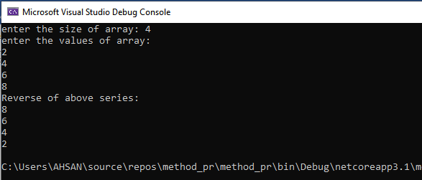

1. Design a fully functional calculator using function.

**Solution:** static int add()

{

int a, b;

Console.Write("\nenter any integer number: ");

a = int.Parse(Console.ReadLine());

Console.Write("enter another number: ");

b = int.Parse(Console.ReadLine());

int result = a + b;

return result;

} static int sub()

{

int a, b;

Console.Write("\nenter any integer number: ");

a = int.Parse(Console.ReadLine());

Console.Write("enter another number: ");

b = int.Parse(Console.ReadLine());

int result = a - b;

return result;

} static int mul()

{

int a, b;

Console.Write("\nenter any integer number: ");

a = int.Parse(Console.ReadLine());

Console.Write("enter another number: ");

b = int.Parse(Console.ReadLine());

int result = a * b;

return result;

} static int div()

{

double a, b;

Console.Write("\nenter any number: ");

a = double.Parse(Console.ReadLine());

Console.Write("enter another number: ");

b = double.Parse(Console.ReadLine());

double result = a / b;

return result;

}

static void Main(string[] args)

{

Console.WriteLine("Which action do you want to perform?");

Console.WriteLine("1) Addition\n2) Subtraction\n3) Multiplication\n4) Division");

Console.Write("select your choice from above: ");

int res = int.Parse(Console.ReadLine());

if (res==1)

{

Console.WriteLine("Addition = " + add());

}

else if (res==2)

{

Console.WriteLine("subtraction = " + sub());

}

else if (res==3)

{

Console.WriteLine("multiplication = " + mul());

}

else if (res==4)

{

Console.WriteLine("Division = " + div());

}

else

{

Console.WriteLine("\n INVALID CHOICE");

}

**Output:**